**How To Tell: If connections to SQL Server are pooled (or not)**

Have you ever wondered if the applications connecting to your SQL Servers are using pooled connections or not? If the answer is yes then read on. However, if the answer is no then you should! Opening and closing connections is an expensive process. When applications don’t use a connection pool then each request needs to establish its own connection before the query can be executed. It then has to close it. A pooled connection is one which is kept open by an application for other requests to re-use.

The question therefore remains how do you actually find out if an application is using connection pooling or not? Well SQL Trace can tell you. If you execute the following statement you will see exactly which category/event and column you need to select to get at this information.

SELECT cat.name AS category_name  
 ,evt.name AS event_name  
 ,col.name AS column_name  
 ,sub.subclass_name   
FROM sys.trace_subclass_values sub  
JOIN sys.trace_columns col ON sub.trace_column_id = col.trace_column_id  
JOIN sys.trace_events evt ON sub.trace_event_id = evt.trace_event_id  
JOIN sys.trace_categories cat ON cat.category_id = evt.category_id  
WHERE sub.subclass_name like '%pool%'

[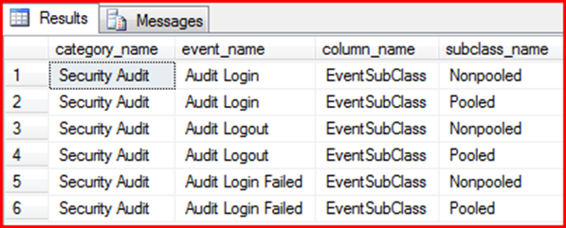](http://blogs.conchango.com/blogs/jamesrowlandjones/image_499102EF.png)

Clearly then we need to open up the Security Audit category and select the audit Login event. To get at this information we must ensure to pick the EventSubClass column. If we were using Profiler to build this trace it would look something like this

[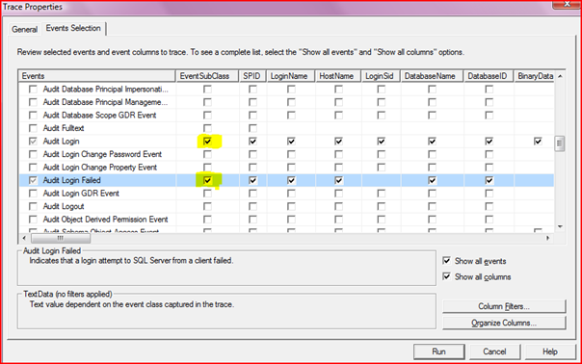](http://blogs.conchango.com/blogs/jamesrowlandjones/image_462F6B47.png)

However, being a good tracer I’d actually want to set my trace up server side and drop the results to a file. To do this I’d export the definition I have just created using File | Export | Script Trace Definition | For SQL Server 2005 – 2008…

[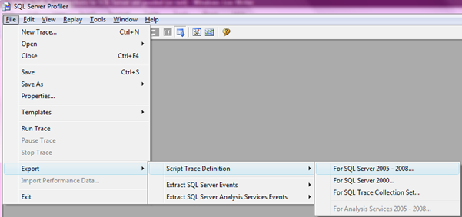](http://blogs.conchango.com/blogs/jamesrowlandjones/image_12574F29.png)

I’d then have a script that looked something like this:

/****************************************************/  
/* Created by: SQL Server 2008 Profiler */  
/* Date: 25/07/2009 20:52:50 */  
/****************************************************/  
  
  
-- Create a Queue  
declare @rc int  
declare @TraceID int  
declare @maxfilesize bigint  
set @maxfilesize = 5   
  
-- Please replace the text InsertFileNameHere, with an appropriate  
-- filename prefixed by a path, e.g., c:\MyFolder\MyTrace. The .trc extension  
-- will be appended to the filename automatically. If you are writing from  
-- remote server to local drive, please use UNC path and make sure server has  
-- write access to your network share  
  
exec @rc = sp_trace_create @TraceID output, 0, N'InsertFileNameHere', @maxfilesize, NULL   
if (@rc != 0) goto error  
  
-- Client side File and Table cannot be scripted  
  
-- Set the events  
declare @on bit  
set @on = 1  
exec sp_trace_setevent @TraceID, 14, 7, @on  
exec sp_trace_setevent @TraceID, 14, 23, @on  
exec sp_trace_setevent @TraceID, 14, 8, @on  
exec sp_trace_setevent @TraceID, 14, 64, @on  
exec sp_trace_setevent @TraceID, 14, 9, @on  
exec sp_trace_setevent @TraceID, 14, 21, @on --EventSubClass  
exec sp_trace_setevent @TraceID, 14, 41, @on  
exec sp_trace_setevent @TraceID, 14, 49, @on  
exec sp_trace_setevent @TraceID, 14, 57, @on  
exec sp_trace_setevent @TraceID, 14, 2, @on  
exec sp_trace_setevent @TraceID, 14, 6, @on  
exec sp_trace_setevent @TraceID, 14, 10, @on  
exec sp_trace_setevent @TraceID, 14, 14, @on  
exec sp_trace_setevent @TraceID, 14, 26, @on  
exec sp_trace_setevent @TraceID, 14, 66, @on  
exec sp_trace_setevent @TraceID, 14, 3, @on  
exec sp_trace_setevent @TraceID, 14, 11, @on  
exec sp_trace_setevent @TraceID, 14, 35, @on  
exec sp_trace_setevent @TraceID, 14, 51, @on  
exec sp_trace_setevent @TraceID, 14, 12, @on  
exec sp_trace_setevent @TraceID, 14, 60, @on  
exec sp_trace_setevent @TraceID, 20, 7, @on  
exec sp_trace_setevent @TraceID, 20, 23, @on  
exec sp_trace_setevent @TraceID, 20, 31, @on  
exec sp_trace_setevent @TraceID, 20, 8, @on  
exec sp_trace_setevent @TraceID, 20, 64, @on  
exec sp_trace_setevent @TraceID, 20, 9, @on  
exec sp_trace_setevent @TraceID, 20, 21, @on --EventSubClass  
exec sp_trace_setevent @TraceID, 20, 49, @on  
exec sp_trace_setevent @TraceID, 20, 57, @on  
exec sp_trace_setevent @TraceID, 20, 6, @on  
exec sp_trace_setevent @TraceID, 20, 10, @on  
exec sp_trace_setevent @TraceID, 20, 14, @on  
exec sp_trace_setevent @TraceID, 20, 26, @on  
exec sp_trace_setevent @TraceID, 20, 30, @on  
exec sp_trace_setevent @TraceID, 20, 3, @on  
exec sp_trace_setevent @TraceID, 20, 11, @on  
exec sp_trace_setevent @TraceID, 20, 35, @on  
exec sp_trace_setevent @TraceID, 20, 51, @on  
exec sp_trace_setevent @TraceID, 20, 12, @on  
exec sp_trace_setevent @TraceID, 20, 60, @on  
  
  
-- Set the Filters  
declare @intfilter int  
declare @bigintfilter bigint  
  
exec  
 sp_trace_setfilter @TraceID, 10, 0, 7, N'SQL Server Profiler - 180a71e3-2916-4eb5-b5cf-cb625d702f39'  
-- Set the trace status to start  
exec sp_trace_setstatus @TraceID, 1  
  
-- display trace id for future references  
select TraceID=@TraceID  
goto finish  
  
error:   
select ErrorCode=@rc  
  
finish:   
go

Note you still have to make some changes to this definition Notably you might want to make the file roll over and you’ll definitely want to change the filename. However, to all intents and purposes you are now good to go and your trace file will generate you something like this:

[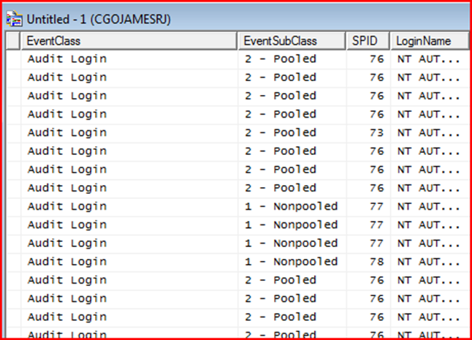](http://blogs.conchango.com/blogs/jamesrowlandjones/image_609C31D3.png)

Hopefully that’s given you enough of a taster to look into this yourself. If you want to know more you might be unsurprised to know that I am writing the SQL Trace chapter for this new SQL Internals book I am working on. I got quite excited the other day as it appeared on [www.amazon.co.uk](http://www.amazon.co.uk/Professional-Server-2008-Internals-Troubleshooting/dp/0470484284/ref=sr_1_2?ie=UTF8&qid=1248552553&sr=8-2) for the first time. My name isn’t up in lights just yet (I think they need to do another refresh from the publishers as I joined the project late) however it is very exciting.

Till the next time,

James